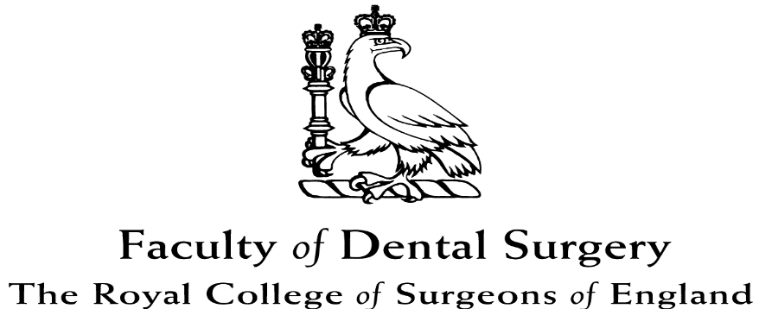

Application Guidance

Licentiate in Dental Surgery (LDS)

Guidance on completing the LDS Part 1 online application

Applicants for the LDS Part 1 examination are advised to read this guidance carefully before making your online application.

Licence in Dental Surgery Part 1 Online Application Guidance

Please ensure that when you apply for your examination online, you have all the required supporting documentation ready to send to the College as these documents must be completed and submitted in full within two weeks of your online application.

Please do not apply online if you have any documentation missing or incomplete. It is expected that candidates will be ready to post documents as soon as they apply online. Where an application is incomplete or supporting documents are not received within two weeks, your application for an examination place will be rejected.

The name you give on your application must be the name on your passport and degree certificate. If it is not, please see the section on Name Change in this guidance. You may not put your title as Doctor (dr) unless you hold a doctorate in addition to your primary dental qualification.

You must include your most up to date contact address, a working email address and at least one contact telephone number.

Please ensure that your details are correct and accurately completed online before you submit your documents.

Please note that when applying for the LDS Part1 online you will be required to enter your payment the examination fee at the time of booking.

Items required within two weeks of the date of your online application:

- Final degree certificate

We require a copy of your final degree certificate. A Notary Public, Commissioner of Oaths, Justice of the Peace or another person entitled to practise law or an authorised officer of an embassy or consulate (referred to as an appropriate individual) must verify and sign the back of the copy of your certificate stating that the copy you have supplied is a copy of the original document that they have seen. A provisional certificate will not be accepted in the place of a final degree certificate or diploma. If you are not able to provide a final degree certificate please contact the office prior to application.

- NARIC certificate

Evidence of your primary dental qualification must be supported by a NARIC Statement of Comparability. For information on how to obtain this, see http://www.ecctis.co.uk/naric/Individuals

Please note for NARIC certificates that it can take time to obtain these so ensure you have your NARIC prior to applying online.

- Passport

You must send in a copy of your current, valid passport verified by an appropriate individual. The individual must verify and sign the back of your passport page copy stating the copy you have supplied is the copy of the original. You can also supply a correctly certified copy. A certified or verified copy of the passport must be clearly legible and the photograph must be clear. The copy must show your photograph and the expiry date of your passport. Only passports that have not expired will be accepted. If you are not able to provide a copy of your passport, please contact the office prior to application.

Translations – any required documents which are not in English must be accompanied by an exact translation. You must send us a certified copy of the original document and correctly certified translation.

The translation must either be a certified translation by a qualified translator or for degree certificates and diplomas, an official translation by the relevant university with the official stamp of the university and the signature and name of the dean.

- Name Change

If the name on your application differs from that on any other documents which you send once you have applied online, you must give us evidence of the legality of your name change, for example a marriage certificate. You can provide a copy verified by an appropriate individual. The individual must verify and sign the application form stating that a photocopy you have supplied is a copy of the original or you can provide a copy.

IMPORTANT NOTICE

Resits:
You do not need to provide original attested documents if you have already sat the
LDS Part 1 examination before.

Original attested copies:
All attested copies must state “This is a true copy of the original”, and must be officially stamped by the awarding body, Lawyer, Solicitor, Notary Public or UK GDC registrant.
The UK GDC registrant number must be included.
The attested original copy must also be signed and dated.

We do not accept electronic copies.

Contacting the Royal College
For any queries regarding the application process please contact the Examinations and Assessment Department at:

The Royal College of Surgeons of England
Examinations and Assessment Department
35-43 Lincoln’s Inn Fields
London WC2A 3PE

Telephone: +44 (0)207 869 6281
Email: dental@rcseng.ac.uk
Web: www.rcseng.ac.uk

