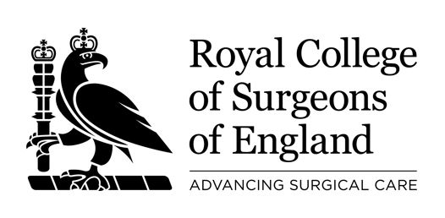

Royal College of Surgeons of England Surgical Specialty Lead: Cranial Neurosurgery

The Royal College of Surgeons of England and SBNS are pleased to invite applications for the role of National Surgery Specialty Lead (SLL) for Cranial Neurosurgery.

This role will complement the existing SSL for Spinal Neurosurgery (Mr Aminul Ahmed) and is supported by two associate SSLs (trainees).

The successful candidate will join the Academic Committee of the SBNS and is expected to attend two in person RCSEng Surgical Trials Initiative meetings per year in London. The appointment is for 3 years and may be once-renewable by mutual agreement.

The role will commence 1st July 2026.

Applications are sought from current SBNS full members with a cranial neurosurgery practice and clinical trials and research experience. The completed application form should be submitted by ******* to the RCS England Clinical Research Manager Murat Akkulak makkulak@rcseng.ac.uk. Candidates will be interviewed by the RCS England Director of Clinical Research (Professor Tom Pinkney) and neurosurgery representatives on *********

If you would like to discuss the role please contact the current neurosurgery SSL Professor Michael Jenkinson (michael.jenkinson@liv.ac.uk).

The Job description is attached.

